# Database Backup Document

Below steps needs to be followed while taking database backup.

* Open Microsoft SQL Server Management studio.
* Once done, expand the Databases node on the left side corner of the window.



* Right click Kewaunee database, context menu will appear.
* In that select Task, in that select Backup option.
* Once selected backup window will get popped up.

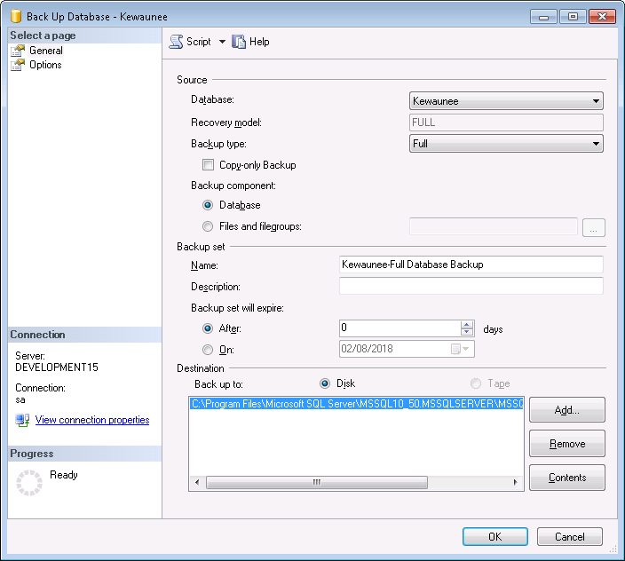

* Enter file name in file name textbox , that will be name of the backup file.
* Click Add button to browse where the database has to be saved.

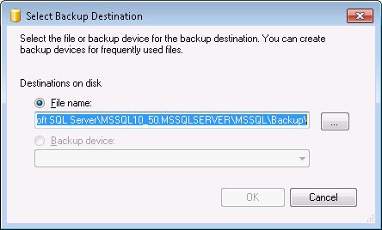

* Once clicked add button, browse dialog will be popped up.
* Select browse button to select path.

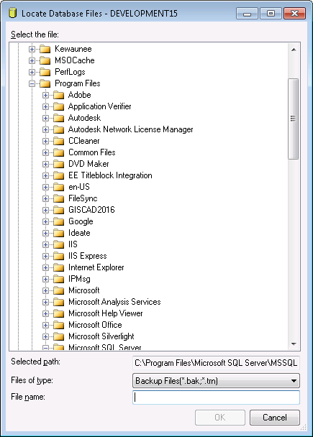

* Backup file will not be saved into local machine rather will be saved into server machine.
* Enter file name and select path and click ok.
* Once done, the path you selected will be displayed in destination box.

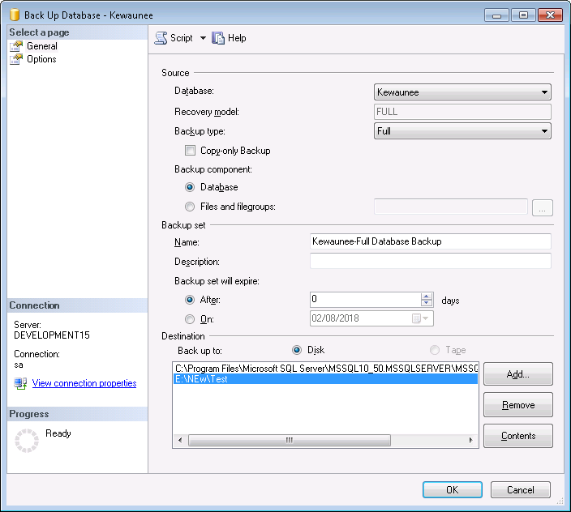

* Select path and click ok to proceed to backup.
* Once done the backup file will be created in the destination folder.